Additional file 7: Thematic analysis of free text comments

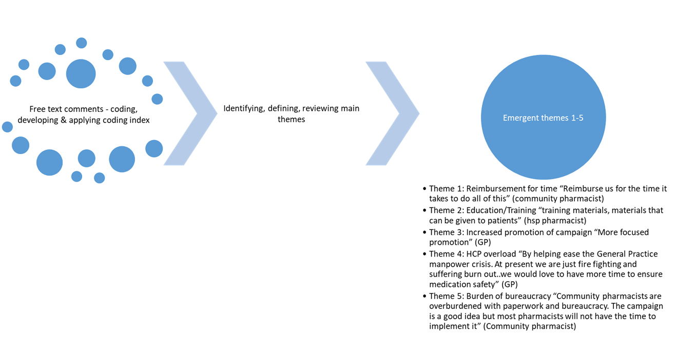
Figure 1: Thematic analysis of free text comments to survey Q28. ‘How could the HSE help GPs to promote the 'Know Check Ask' message and use of medicine lists?’

