Additional file 2: Consolidated Framework for Implementation Research and Theoretical Domains Framework

Domains of Consolidated Framework for Implementation Research
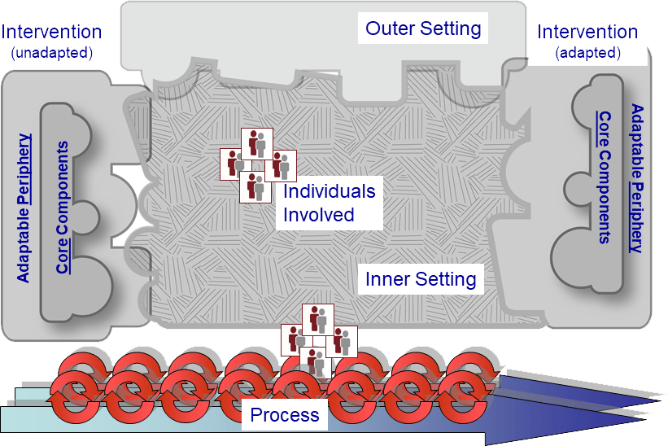

[Retrieved from cfirguide.org]

Domains & constructs of Theoretical Domain Framework (v1)

TDF domains 1-6 | Constructs | TDF domains 7-12 | Constructs
1. Knowledge | Schemas/mind-sets | 7. Memory attention & decision processes | Memory; attention control; decision making
2. Skills | Coping strategies;  ability | 8. Environmental context & resources | Environmental stressors; resources
3. Social/professional role and identity | Identity/role | 9. Social influences | Social pressure/norms; group conformity; social support; alienation
4. Beliefs about capabilities | Self-efficacy; self-confidence | 10. Emotion | Fear; anxiety; affect; stress
5. Beliefs about consequences | Attitudes; appraisal | 11. Behavioural regulation | Self-monitoring; action planning; barriers & facilitators
6. Motivation & goals | Intentions; goals/goal priority | 12. Nature of the behaviours | Routine/habit; direct experience

